 |  | TERMO DE ACEITE TÉCNICO
Solicitante: VIVO- Projeto Escolas Rurais
NOC/Operador: Rogerio Momi Frias |  |  | Cliente: VIVO
Empresa  EMC Brasil | VSAT-ID  VIVO-PER- |  | Link kbps  256/128 | Plataforma  VSAT
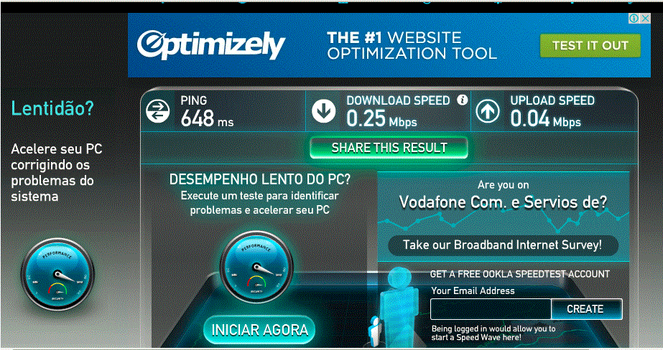

Satellite (DVB) RX Configuration
--------------------------------
Auto start : Enabled
Max MODCOD : 23 16APSK-9/10 (SNR threshold: 23.5 dB)
RX watchdog : 15 minute

Idx Pri SymbRate[Msps] Freq[GHz] Mode PopId Enable
* 0 0 9.320000 12.055825 DVB-S2 4 Yes
1 1 0.000000 0.000000 DVB-S2 2 Yes

Satellite (DVB) Receiver Status
--------------------------------
Rx State : On
DVB State : Forward link up
Network : 1326, GlobalIP@Telstar-14R
Frequency : 12.055823 GHz
Symbol Rate : 9.319847 Msps
S2 ModCod
- receiving : 1 QPSK-1/4
- current max : 23 16APSK-9/10
Pilot : On
Frame length : Short
DVB S2 Mode : ACM
Roll off : 0.25
SNR : 14.0 dB
Input Power : -20 dBm

Satellite (DVB) TX Configuration
--------------------------------
Auto start : Enabled
IDU Output Power : -30 dBm
IDU Max Output Power: 0.0 dBm
ODU Output Power : 33.0 dBm
EIRP : 46.3 dBW
Default CW Frequency: 0.000000 GHz
ATM mode : VC-Mux
Header Compression : None

Satellite (DVB) Transmitter Status
--------------------------------
State : On (TDMA)
IDU Output Power : -22.7 dBm
ODU Output Power : 35.0 dBm
EIRP : 48.3 dBW
Es/No : 15.0 dB
Header Compression : Disabled
Timing correction : -224 us (262569 us)
Frequency correction: -170 Hz
